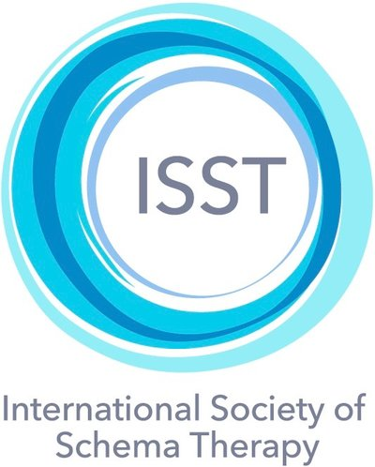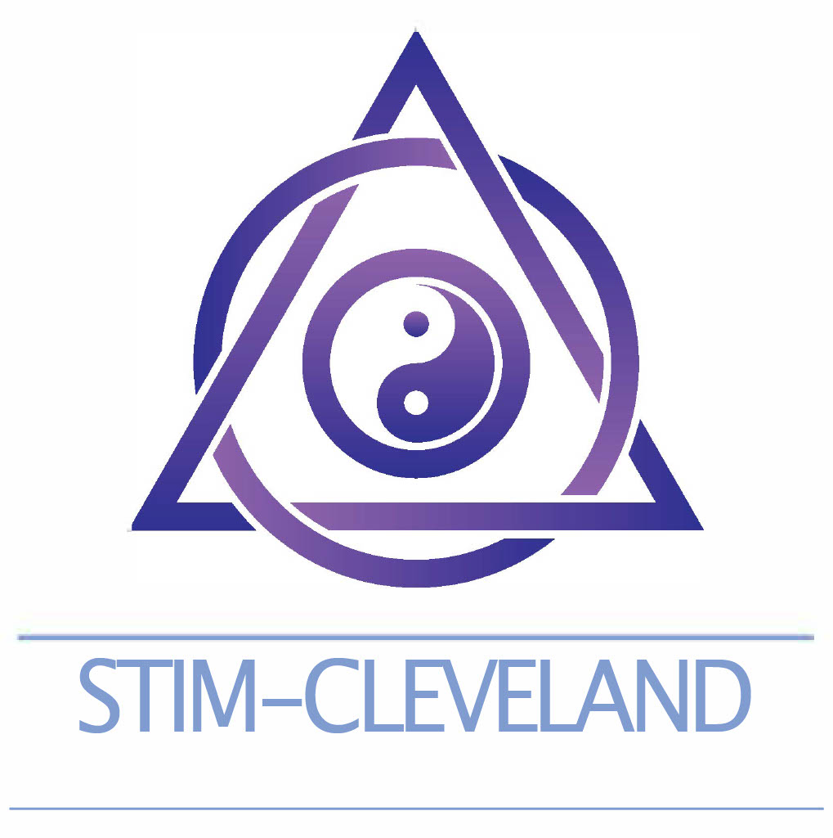

2027
Registration Form: Advanced Group Schema Therapy Certification Training
March 18, 19 & 26. 8:30-4:00 (EST)

Participant’s Name: ____________________________________________

Mobile Number: ____________________________________________________________________________

Postal Mailing address

E-Mail Address: _____________________________________________________________________________

State/Country: _____________

Certified in Schema Therapy: Yes _________ No ___________ In Process _____________

Please describe here how you meet the ISST requirement that you are either licensed to practice psychotherapy independently (for countries with licensing) or that you have the required alternative professional organization membership in your country.

License #/country________________________________________________________________________
or
Professional organization registration ________________________________________________

Having attended Standard level GST Training is a prerequisite to attending Advanced GST training. Applicants who can demonstrate adequate group and schema therapy experience will be considered on an individual basis. Please email Dr. Farrell to be considered without Standard level training.

We follow the ISST guidelines regarding online attendance requirements for receiving certification credits (see attached). Whole-day attendance is required to receive full credit. The Self-Therapy day is one of the Standard level GST certification requirements thus not optional. Participants who attend the complete 3-day training will receive a certificate of completion for the training part of Standard GST certification.

Payment of Tuition: $750. USD without VAT or other country taxes.
Payment from the US is requested by Zelle. If made by paypal or wire transfer fees will be charged to the applicant. No additional fees for Venmo or WISEA PayPal invoice for those who choose this method will be sent from stim-cleveland@gmail.com. Bank wire transfers and other payment info sent on request.
A deposit of $200. USD$ will hold your place should be made after your application is accepted. The remainder of the tuition ($550. USD) will be payable by March 7. If you need to make payments in smaller installments over time, please notify us and we will discuss that arrangement. If you cannot participate after payment has been made due to illness or other emergency, at the discretion of the director, you may have the option to apply unused monies that you have paid to a future program. You may also substitute another qualified participant in your place using your fees paid. Some reduction in fees can be made for those in emerging countries based upon financial need.

EMAIL REGISTRATION FORM TO: drjoanfarrell@gmail.com
Required: Please put an X in the boxes below and add your name and date on the line indicated. Please type your name and date or use an electronic signature.
□ I understand that space is limited, and the training is only financially feasible based on the guarantee of a minimal number of accepted participants. Therefore, I understand that once my application is accepted and monies have been paid, there will be no reimbursements or refunds under any circumstances. In the event that illness or emergency prevents your participation, arrangements will be made for you to view the portions of training that you missed.
By placing an X in the box above -- and by typing or signing my name and the date on the lines below -- I am accepting these terms as a binding agreement.

_____________________________________________________________________
Type or Sign Your Name Date

