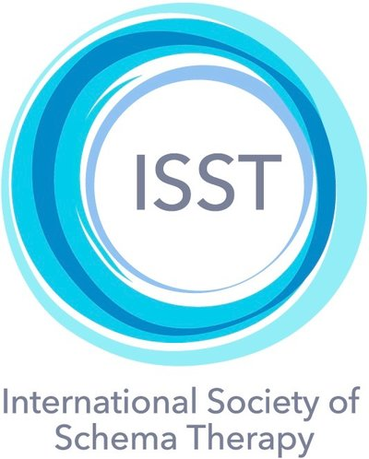

Registration Form: Group Schema Therapy Training

Participant’s Name: ____________________________________________

Postal Address: _______________________________________________________

_________________________________________________________________________________________________

Phone Number: _____________________________________________________________________________

Mobile Number: ____________________________________________________________________________

E-Mail Address: _____________________________________________________________________________

Discipline:

( ) LCSW ( ) Masters Level Counselor
( ) Psychologist ( )Ph.D, Psy.D. ( ) Master’s degree. ( ) Psychiatrist ( ) Other (specify) ________________________

State/Country: _____________

Years in Professional Practice: ____________________

Current Place of Employment: ___________________________________________________________

Certified in individual Schema Therapy: Yes _________ No ___________
In Process ______________

Your Experience with Schema Therapy: _______________________________________________

A prerequisite to attend GST training is having attended at least 12 hours of training in the basic model of ST. If you are not certified in individual ST or in the process of ST training, please describe below how you have met this requirement.
We strongly recommend you purchase and read Farrell, Reiss & Shaw, The Schema Therapy Clinician’s Guide: A complete resource for building and implementing individual & group schema therapy, Wiley-Blackwell, 2014.

We follow the ISST guidelines re: online attendance requirements for receiving certification credits (see attached). Whole-day attendance is required to receive full credit. The Self-Therapy day is one of the Standard level GST certification requirements thus not optional. Participants who attend the complete 4 day training will receive a certificate of completion for the training part of Standard GST certification.

Payment of Tuition: $1,050. For 4 days
A Paypal invoice will be sent to you from BASEConsulting@sbcglobal.net
for a deposit of $250. USD$ Payable by September 15, 2023. A second invoice for the remainder of the tuition ($800. USD) will be sent and payable by October 15. If you need to make payment in smaller installments, please notify us and we will make that arrangement. If you are in a country unable to use Paypal also contact us and we will make other arrangements with you. If financial hardship prevents your participation, let us know as limited scholarships are possible for eligible applicants. If you cannot participate after payment has been made due to illness or other emergency, space permitting, and at the director's discretion, you may have the option to apply unused monies you have paid to a future program.

EMAIL COMPLETED REGISTRATION FORM TO: drjoanfarrell@gmail.com
Required: Please put an X in the boxes below and add your name and date on the line indicated. Please type your name and date, or use an electronic signature.
□ I understand that space is limited, and the training is only financially feasible based on the guarantee of a minimal number of accepted participants. Therefore, I understand, once my application is accepted and monies have been paid, there will be no reimbursements or refunds under any circumstances. In the event that illness or emergency prevents your participation arrangement will be made for you to view the portions of training that you missed excluding the self-practice day. By placing an X in the box above -- and by typing or signing my name and the date on the lines below -- I am accepting these terms as a binding agreement.

_____________________________________________________________________
Type or Sign Your Name Date

